

The Newsletter of
Goulburn & District Arts & Crafts Inc.
www.galleryontrack.org
Telephone: 4822 7889
The Centre for Community Creativity
July 2012
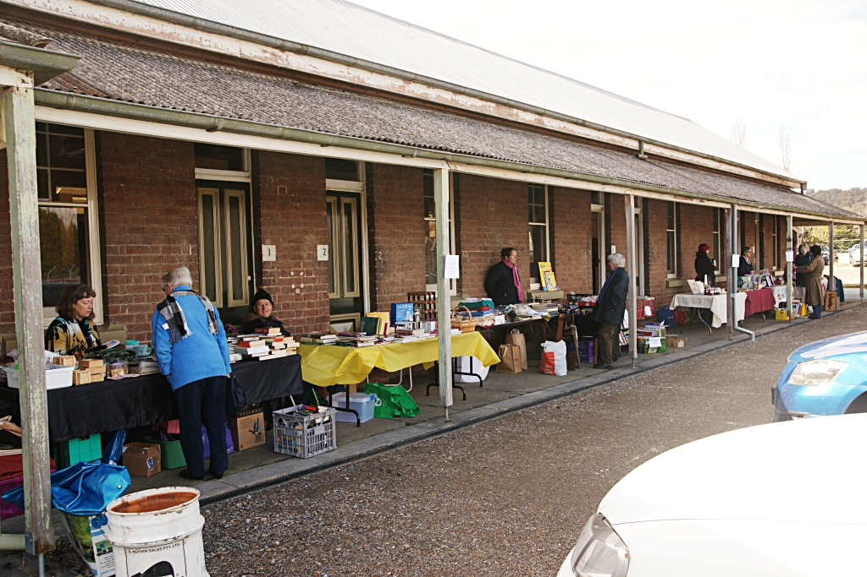
The sun was shining, but they weren’t in the sun; the wind had long fingers which snuck down the tiniest gap and froze eyelashes – despite frozen feet and noses, the garage sale participants (all 9 of them) sold a few items, spruiked the gallery and GDAC and had a very convivial time.

Although the shady side of the building was not the best choice for the Garage Sale, we managed to put eleven tables – which we couldn’t have fitted on the sunny side – and everyone was kept busy with browsers and buyers.

The turnout of the public was really excellent – a very rough guess – about 80 people, most of who wandered into the gallery. Everyone who went in came out praising the high quality of the work and promising to come back with their mothers or friends. It was a great public relations exercise, as hopefully all those people will tell others about the gallery - and the stall holders got rid of some of their stash.

The stall holders got to know each other better, had some fun and were asking when the next one would be – the almost shouted, unanimous answer was, “Spring!!!”


OPENING HOURS
The opening hours have been changed to Wednesday to Sunday 10am – 4pm.

SIGNAGE
The Committee approved the design and colours for the Gallery signage and proofs were shown at the General Meeting on Saturday, 7 July. Soon, there will no more fighting the wind to put up the banners Anna Shead kindly organised as a temporary measure. (The signs look gorgeous, although the colour hasn’t come out well here - the writing will be the same colour as the present banner.) There will be permanent signage at the beginning of Blackshaw Road, as well as on the ARTC sign. This should make a huge difference to the Gallery’s visibility. Many thanks to Jean Townsend for organising the design and production through SignageOne.

The banners won’t be wasted, as they could be used when members attend fairs and markets and would like (and who wouldn’t?) to promote our Gallery – or use the insurance.

GENERAL MEETING
It was great to see so many new members at the General Meeting on Saturday, 7 July.

Fiona Hammond discussed some terrific ideas for workshops and publicity, the advertisements in the Cultural Heritage Book and Goulburn Tourist Information book were passed around and Tig Hobcroft joined the publicity committee (thanks, Tig). Norbert Elberich suggested that business cards be printed, as these are easy for members to hand out at various venues – that was such a good suggestion, that the design and printing of 2,000 are underway. Also underway is the printing of flyers to go to Tourist Information Centres (if you can spread them around your area that would be excellent) and other touristy places.

SOUP & SCONE DAY
Absolutely not to be missed is our next SPG (Special General Meeting ) on 4 August in the Crib Room at 10am. The Committee is cooking soup and scones for lunch (multi-talented is that Committee!); a quick business meeting and Carol will give a demonstration and talk about her passion - felting.

We will have a display table – please bring some work of yours to show fellow members, because, not only are we all interested in everyone else’s passion, but it would be great to have a page in this newsletter about people’s work. The more we know about what you do, the better we can sell it by talking knowledgably about it. Photos will be taken and included in the next newsletter.

COMMITTEE
Welcomed to the Committee until the AGM, were Carol Divall as Chair, Elaine Bill, Fiona Hammond and Jean Townsend. These appointments mean that there is now a full Committee – and even more talented people growing GDAC.

MAINTENANCE
Needed urgently. A couple or three or four people who can take care of the maintenance of the building. There are always little jobs which need doing – such as photographing the water meter on the 1st of every month, little fixups and just keeping an eye on the fabric of the building, so that major repairs don’t become urgently necessary. No, you don’t have to be a handyperson wearing a tool belt – just practical and observant.

If you can keep an eye on things, please ring Robyn Primrose 4823 6110 or email p-rose@primroses.org to volunteer.

GOINGS ON
- A fabulous idea for an exhibition in February, 2013 has been created by Carol Divall. "BODY of WORK", an exhibition about body decoration at Gallery on Track, February 2013. Entry fee $20.00. Any medium. Some "bodies" available at Gallery on Track
Members choice PRIZE $100.00
Entry forms available shortly, Queries, phone C. Divall 48212 572
- There are still places for Artist of the Month – please ring Carol 4821 2572
- People on roster are always needed. Perhaps you could be a ‘fill in’ for odd days when needed? Ring Lynette 4821 1959
- One of our organisation members, Crookwell District Arts Council has a new website - www.crookwellgallery.com Have a look. CDAC is really gearing up with some terrific exhibitions and happenings.
- There will be a GDAC email address shortly.
- We have been open 26 days and the average daily sales are $131.06. That doesn’t sound bad, but we only get 20% of that and have to pay 10% GST on our commission. Certainly signage and flyers will help increase sales, but so will telling everyone you know where the Gallery is and how terrific is your work.

A LITTLE ISSUE
You may not be aware, but as a legal requirement, any garment sold must have care instructions sewn into it. It is not sufficient to have a separate tag attached to the garment. One website selling sew in labels is flashlabels@ozemail.com.au Please make sure labels are sewn in or the work may be rejected.

MEMBERSHIP
Membership fees were due by 30 June. Remember, we need your membership to run the gallery.

Please renew your membership as quickly as possible as to nominate for the Committee and vote at the AGM, you must be a financial member.

Which segues into…….

ANNUAL GENERAL MEETING
The AGM will be held on 15 September. There will be a Special General Meeting opening at 10am, followed by the AGM at 11am.

The business of the AGM was covered in the last newsletter. All positions are declared vacant. Those positions are:

President, Vice President, Secretary, Treasurer, four ordinary Committee members and the Public Officer. The outline of duties for each position are as follows (and they are not as scary as they sound):

- The specific duties of the President are:

- Ensure that members understand their jobs and are able to fulfill those expectations; and
- Chair meetings of the GDAC; and
- Help recruit new members and develop succession plans for CoM chairs; and
- Provide structure so that the work of the board and association can be accomplished; and
- Ensure that management tools are developed and implemented; and
- Work with sub-Committees. The President may serve as an ex officio member of the board’s various sub-Committees; and
- Serve as a link to the broader community. The President must be prepared to act as the public face of the GDAC: addressing issues with the media, lobbying and promoting the GDAC to prospective funding bodies and donors; and
- Report to members at the AGM.

- The specific duties of the Vice-President are:

- Performs the President’s responsibilities when the President cannot be available in accordance with Rule 93(a, b, c, d, e, f, g, h); and
- Work closely with the President; and
- Participates closely with the President to develop and implement officer transition plans; and
- Perform other responsibilities as assigned by the CoM.

- The specific duties of the Treasurer are:

- To ensure that all monies due to the association are collected and received and that all payments authorised by the association are made; and
- That correct books and accounts are kept showing the financial affairs of the GDAC, including full details of all receipts and expenditure connected with the activities of the GDAC; and
- Present a financial statement at each GM: and
- Report to the members at the AGM.

- The specific duties of the Secretary are:

- To keep records of:
- All appointments of office-bearers and members of the CoM; and
- The names of members of the CoM present at GMs; and
- The names of all present at AGM and SGM; and
- All proceedings at all meetings; and
- Have the Register of Members available at the AGM; and
- Deal with all correspondence of the GDAC, and disseminate it as appropriate.

The Public Officer

- The Public Officer is the official point of contact for the GDAC, they can also be one of the authorised signatories.

- A CoM member or an ordinary member or a person outside of the GDAC may hold the position of Public Officer.

- They must be over eighteen (18) years of age and reside in New South Wales.

- The CoM will appoint the Public Officer when a vacancy occurs.

GDAC has a fabulous new space, wonderful work coming in and needs energetic, interested people to run it. Please be one of those people! You will be working with like-minded people in a co-operative and supportive committee. The previous committee members will give you help to make the transition smooth and pain free. What an exciting idea to take the Gallery and GDAC through the first year (yes, it is, really) and shape its future.

In order to get the voting papers out by mail, nominations need to be in very quickly. A nomination form is attached, so please think and act and return your completed nomination form to the Secretary, Lynette Brown at PO Box 193 Goulburn, or email it to lynrod@tpg.com.au by 1 August.

A favourite quote, thrown in for no reason…...."Great things are done by a series of small things brought together" Vincent Van Gogh (Passed on by Katherine Ward, thanks)

SAVE THE DATE
12 July – 5 August Artist of the Month – Robyn Toohey (Milliner)
22 JULY – Carol Divall – Hat or Bag Felting Workshop
5 August – ‘Meet the Milliner’ Meet Robyn Toohey and for discussion on her stunning hats. 2-2.30pm
4 August – Soup & Scones -General Meeting 10am Crib Room
15 - 29 August – TAFE Photographic Exhibition Opening 18 August, Time TBA
11-12 AUGUST – Chan Dissanayake Watercolour Workshop
19 August – Carol Divall Hat or Bag Felting Workshop
26 September – Artists of the Month Marolyn Turner and Enid Worthington (Silk works)
15 SEPTEMBER – ANNUAL GENERAL MEETING
December – Mid-January Artist of the Month Kathy Guerts (Workshops in January)
February, 2013 - ‘Body of Work’ a members’ exhibition $20 entry
March, 2013 - Goulburn’s 150th Birthday as a City – Fashion and Photos – Past and Present
May 2013 - Artist of the Month – Carol Bairnsfather

This project is funded by; Soldiers’ Club, Goulburn Workers Club and the following bodies;



Goulburn & District Arts & Crafts Inc. ABN 23 462 827 448 Gallery on Track Blackshaw Road, Goulburn NSW 2580, PO Box 193, Phone; 48227889, NOMINATION FORM
For Annual General Meeting September 2012

I HEREBY nominate ……………………………………………………………………………………………………………………………….

For the position of…………………………………………………………………………………………………………………………………..

Signed

…………………………………… ………………………………………….
Proposed by Print Name

…………………………………… …………………………………………
Seconded by Print Name
I hereby accept the nomination. ………………………………………………
Goulburn & District Arts & Crafts Inc. ABN 23 462 827 448 Gallery on Track Blackshaw Road, Goulburn NSW 2580, PO Box 193, Phone; 48227889, NOMINATION FORM
For Annual General Meeting September 2012

I HEREBY nominate …………………………………………………………………………………………………………………………………….

For the position of………………………………………………………………………………………………………………………………………

Signed
…………………………………… ………………………………………….
Proposed by Print Name
…………………………………… …………………………………………
Seconded by Print Name

I hereby accept the nomination. ………………………………………………

