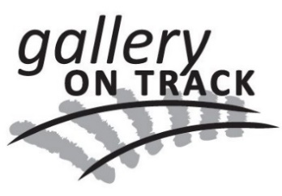
Goulburn and District Arts and Crafts Inc. Trading as Gallery on Track
If paid at the Gallery:
Paid by:
Card / cash / cheque / bank transfer
(circle one)

Date Paid: ………………………………

Received by (volunteer name)

…………………………………………….
ABN 23 462 827 448
PO Box 193, Goulburn NSW 2580 Phone:0248227889
email: galleryontrack@gmail.com

MEMBERSHIP RENEWAL 2020 – 2021
Fee from 1 July 2019 to 30 June 2020 is $30

This form is to be completed and returned to the Gallery by 30 June 2020

Name ________________________________________________Memb. Number _______

Address _____________________________________________________________________

Phone/mobile _____________________________________________________________________

Email _____________________________________________________________________

Business name (if applicable) ________________________________________________________

Art/craft form(s) practised ________________________________________________________

⃝ I wish to continue to place items of my work for sale in the Gallery. I continue to agree with the terms and conditions for selling work in the Gallery as outlined in the Information for Members document, and amended from time to time, and my bank details currently registered with the Gallery have not changed

⃝ I will mind the Gallery for 1 x 6 hour shift OR 2 x 3 hour shifts every 4 weeks (please indicate)

Preferred day(s) Wednesday Thursday Friday Saturday Sunday

I am paying my membership renewal fee of $30 (please indicate)

⃝ by bank transfer to GDAC BSB: 032 721 Account number: 158234
Include full name and membership number

⃝ by cheque made out to GDAC – bring with form to the Gallery or send by post with form to
Membership Secretary, GDAC, PO Box 193, Goulburn NSW 2580

⃝ by card at the Gallery

⃝ by cash at the Gallery

Signed and dated ________________________________________________

OFFICE USE ONLY
Payment checked __________________________________________
Member details updated __________________________________________

